**Webpage development in Native Language**

About yourself: (in 10 lines)

Name: XYZ

Gender:

Nationality:

Address: ---

City:

State:

Country:

Pin code:

Hobbies: (in 10 lines)

Read the following example and develop bio data about yourself in native language.

**Sample Example**

<!DOCTYPE html>

<html>

<head>

<title>Satcos-Tamil Web Pages</title>

**<meta http-equiv="content-type" content="text/html; charset=utf-8" />**

</head>

<body>

<p>தமிழ் வலைத்தளங்கள் உருவாக்குவது சுலபம்</p>

<p>தமிழ் வலைத்தளங்கள் உருவாக்குவது சுலபம்</p>

</body>

</html>

Follow these steps to create webpage using our native language

1. In order to use UTF encoding we need to specify character set meta tag in the “Head” section of the html.
2. Use Azhagi+ or Keyman to get the text in your desired language, copy past it in the html document.
3. Save the file as html with utf variant encoding

**Task**

Need to create the following content

கீதாசாரம்

எது நடந்ததோ அது நன்றாகவே நடந்தது

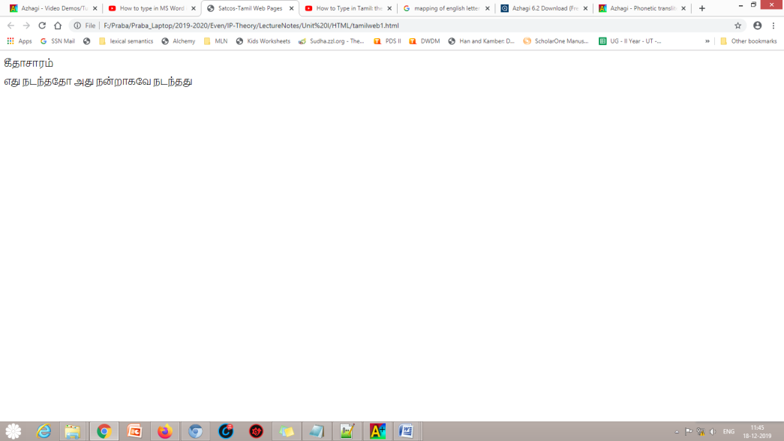

**How to develop a website in native language?**

**Steps**

1. Install free Azhaghi+ software using the link and install (setup file uploaded)
2. Install Notepad++
3. There will be something called existing hotkey in the azhaghi+ software. Note it. By default it is F10.

Open the word

Press F10 to type in tamil

Use keyboard mapping to type tamil letters.

If you want to change to English, type again F10

1. Copy the tamil sentences in the HTML tag as we type English sentences. Type the html code in Notepad++
2. Save as html file
3. Render in browser. You will be able to see a web page created in tamil font